Key Stage 4 Examination Results 2019-20

Key Stage 4 – GCSE / BTEC Results 2019-2020

Data provided will not be used for performance measure / progress 8 etc however Accreditation for 2019-2020 based on CAG and Govt algorithm is reported:

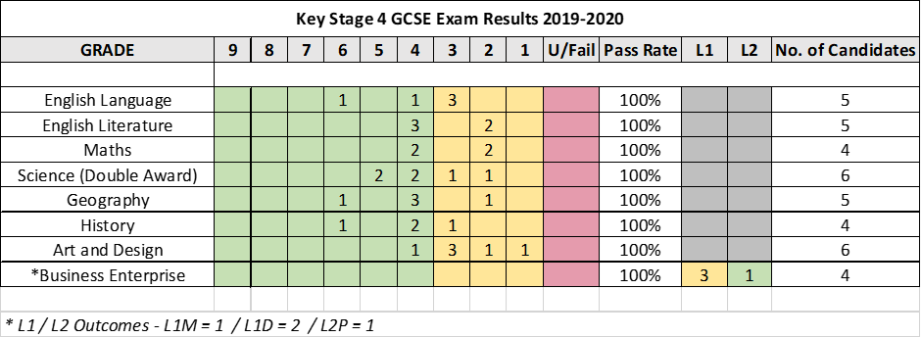

Science Results (Double Award) = 2.1 / 3.2 / 5.5 / 4.3 / 5.4 / 4.4 (3 grades increased from CAG by one grade)
Business Enterprise – 4 Candidates increased grade from CAG

Entry Level Results 2019-2020
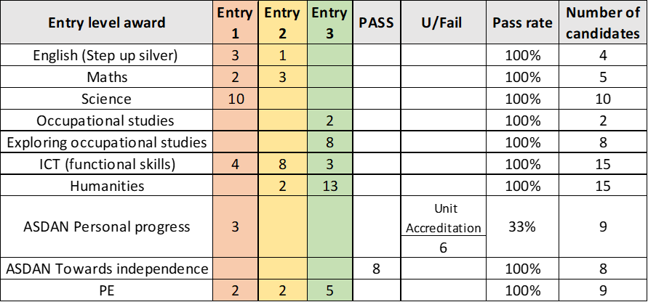

All Grades in line with CAG
All students able to gain unit accreditation for work completed

