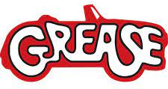  Tac Pac | Action!

* Say hello * Make Contact * Sing *
* Then with music –

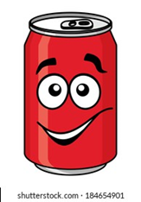  Roll can over student- keep it lively! | - Spray with water spray over hand/arm. Use towel to dry hand/arm in the beat with the music
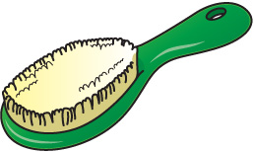  - Brush hair with hair brush. Gentle roll hair brush over hand/arm. | 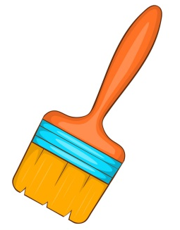  - Use paint brush to make circular motions on hand/arm/face.
- Run Scarf over body parts. Pulling scarf through fingers. | - Placing bracelet on arms. Running beads over hand/arm/.
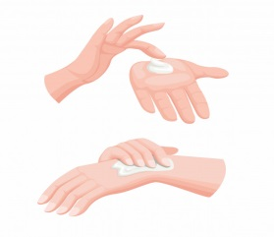  - Use hand cream for gentle hand massage. | You will need:  - Food can  - Spray bottle and towel  - Hair brush  - Paint brush  - Scarf  - Bracelet and beads  - Hand cream

