5.2 English w/b 06.07.20
Good morning 5.2
Your task for this week is below. Please email me, Maxine or Najeeb if you need any help.
Have a good w until we meet on Thursday via Zoom,
Sophie
Task 1:
It is great to see you thinking about your word choices. We use a lot of nouns in our writing – naming words – but we can make our writing much more interesting by adding adjectives.
Look at the jigsaw phrases below. Add two adjectives to help you describe the final word (noun) e.g. hero, ocean, cheese, elephants, bush. The smaller middle piece of jigsaw needs to include a comma to separate the two adjectives you choose.
Here are some pictures that may help you:

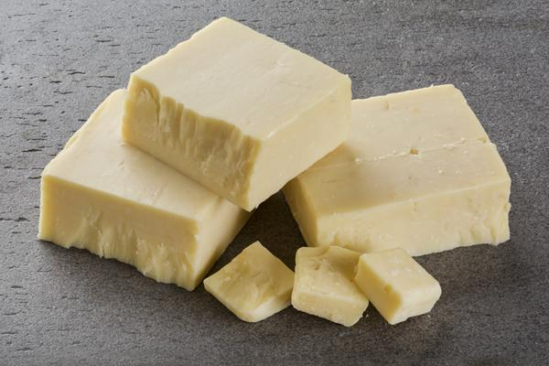

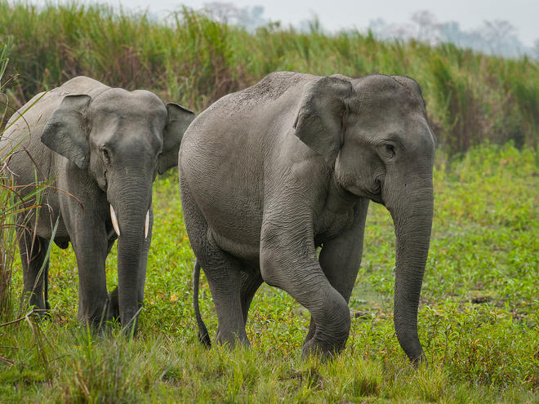
Challenge:
Can you turn two of these phrases into sentences?
Example: The brave, strong hero defeated the beastly dragon.

