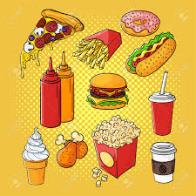
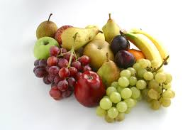
My Favourite Things

My favourite colour is
My favourite food is
My favourite drink is
My favourite TV show is
My favourite singer or song is
My favourite animal is
My favourite cake is
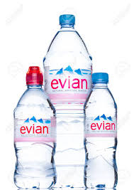
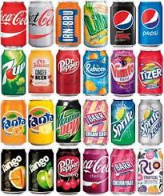

Now ask someone in your family
What Their Favourite Things Are?

…………………’s favourite colour is
…………………’s favourite food is
…………………’s favourite drink is
…………………’s favourite TV show is
…………………’s favourite singer or song is
…………………’s favourite animal is
…………………’s favourite cake is

