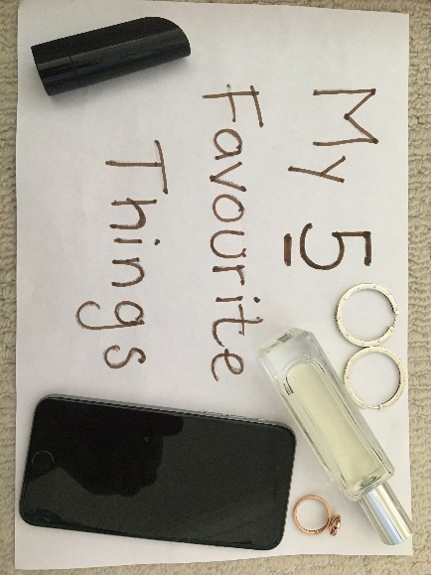

Place five of your Favourite Things on to  
a printed copy of this poster (or design your  
own) and send us a photo.

My 5

Favourite

Things