Table Top
Empty Toilet Roll Skittles
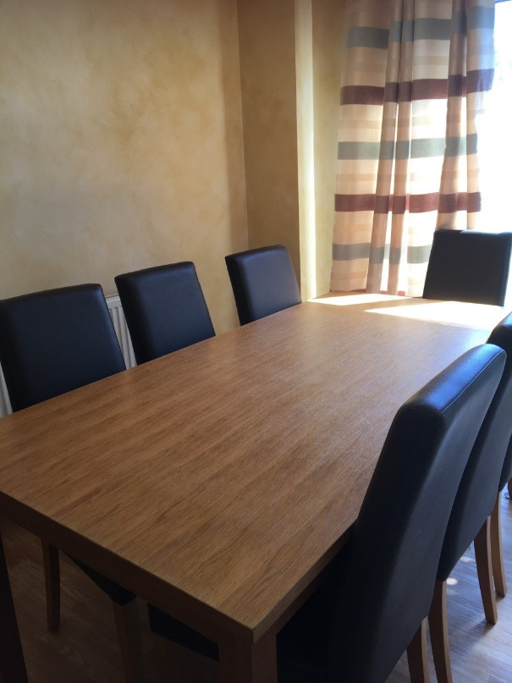
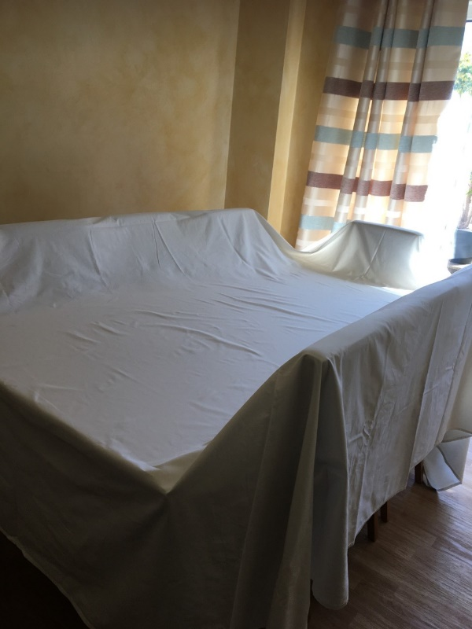

1 Use your Table and Chairs 2 Cover with a Double sheet

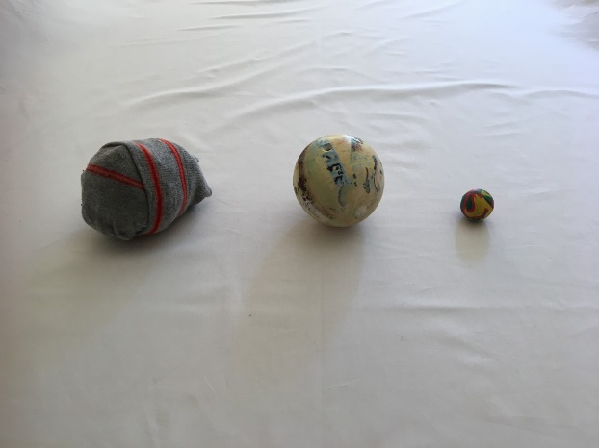

3 Use a rolled up sock or
a small soft ball, if you
have one
4 Set up your empty
Toilet roll skittles

Each player takes a turn, whoever knocks down the most Skittles is the winner

